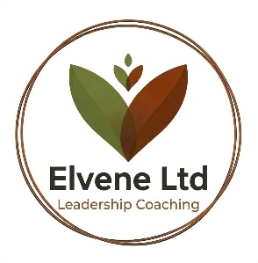

Accessibility Statement

Elvene is committed to ensuring our website is accessible, inclusive, and usable for everyone. We want all visitors to have a positive experience, regardless of ability, technology, or environment. Our goal is to meet or exceed the Web Content Accessibility Guidelines (WCAG) 2.2 AA standard and continually improve accessibility across our digital services.
Our Approach to Accessibility
We take a proactive and thoughtful approach to accessibility by:
- Designing and developing content with clear structure, readable typography, and intuitive navigation.
- Using plain, concise language wherever possible.
- Ensuring our site is compatible with assistive technologies such as screen readers, magnifiers, and voice-recognition software.
- Providing sufficient colour contrast and avoiding reliance on colour alone to convey meaning.
- Making interactive elements easy to use with a keyboard and other input methods.
Ongoing Improvements
Accessibility is an ongoing commitment. We regularly:
- Review and update our website content and design.
- Test pages using automated tools and manual checks.
- Address issues identified through audits, user feedback, or new accessibility standards.

Known Limitations
While we strive for full accessibility, some areas may not yet meet WCAG 2.2 AA standards. We are actively working to improve:
- Legacy content that may not fully align with current guidelines.
- Third-party integrations that are outside of our direct control.
Feedback and Contact Information
We welcome feedback on the accessibility of our website. If you encounter any barriers or need information in an alternative format, please contact us:
Email: claire@elvene.co.uk Response time: We aim to reply within 3 working days.
Commitment to Continuous Improvement
Elvene is dedicated to creating an inclusive digital experience. As accessibility standards evolve, we will continue to adapt our website and practices to ensure equitable access for all users.

